Lab Experiments
5. To implement the ε-greedy Multi-Armed Bandit algorithm for an online advertisement recommendation system to maximize user engagement through balanced exploration and exploitation.
Code:
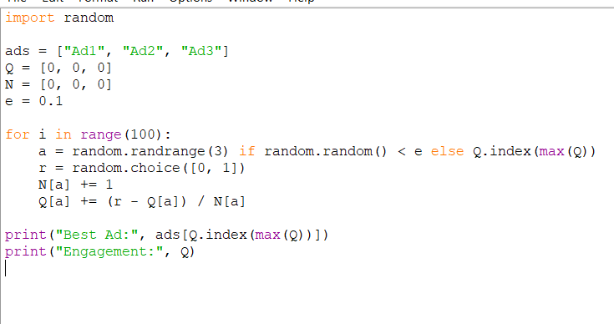

Output:
